



[solar energy]

Authors

[Shahed El Farraj]

Supervised by

Course: 307498 – Graduation Project
First Semester, 2025/2027

Date



Abstract

This project supports generation of sustainable electricity using solar power, which has become a main source of renewable energy for power generation in Jordan.
This business intelligence and machine learning solution supports users of SolarWise in estimating generation of solar energy.
We utilized six years of historical weather information from NASA’s POWER database.
The historical weather data included measurements for solar irradiance, clear-sky irradiance, air temperature, relative humidity, cloud amount, wind speed, precipitation, and geographic location of weather observations, The provided data went through various steps of data cleaning, feature engineering, and historical weather data preprocessing. And feature developed and compared, including Linear Regression,Random Forest, and XGBoost. The models were evaluated using MAE, RMSE, and R2 to select the most accurate predictor.

The results showed that XGBoost achieved the best prediction error and the highest coefficient of determination (R2). Feature importance analysis also showed that solar irradiance and cloud cover are the most influential factors affecting solar energy generation . In addition, the project provides practical outputs, including identifying the most suitable locations for solar energy investment in Jordan and estimating potential household saving using the local electricity tariff.

Finally, the trained model was integrated into the solarwise application, allowing users to estimate expected solar energy generation and evaluate the feasibility of installing a residential solar power system based on their location.
Acknowledgment

I would like to express my sincere gratitude to my supervisor for the guidance, support, and valuable feedback provided throughout the development of thid graduation project. Their advice and suggestions helped me improve both the technical and analytical aspects of the project.

I would also like to thank my instructors and the department of Business Intelligence for providing me with knowledge and skills that helped me complete this project.

Finally, I would like to thank my family, friends, and everyone who supported and encourage me throughout my university journey and during the completion of this project.

Thank you to everyone who contributed, directly or indirectly, to successful completion of this project.
Business Intelligence Project Description and Objectives

The increasing demand for renewable energy has made solar power an important part of Jordan’s energy sector. Jordan has good amount of sunlight throughout the year, which makes solar energy a suitable option for producing electricity. However, the amount of energy location. Weather conditions and geographic factors such as irradiance, temperature, cloud cover, humidity, wind speed, and location can affect the expected solar output.
Business Intelligence and Machine Learning Project - SolarWise in which we forecast solar generation in various regions of Jordan based on meteorological and geographical data. Data for the project is taken from NASA POWER, spanning 6 years of data from 2020 to 2025. Before establishing Machine Learning models that can learn the correlation between the weather conditions and solar energy generation, the data will be cleaned and analyzed.
The project also seeks to provide practical application of its findings for decision making. SolarWise doesn't just present the result of a prediction by a Machine Learning model; it gives information that can help understand the anticipated solar production at a specific house site. It also can be used to help investors understand and compare the different regions in Jordan and recognize which regions have better solar energy potential.

Project Objectives
* To analyze weather and geographic data related to solar energy generation in Jordan.
* To identify the main factors that affect solar energy production.
* To predict solar energy generation for different locations using Machine Learning.
* To compare different Machine Learning models and select the model with the best performance.
* To identify areas in Jordan with higher solar energy generation potential.
* To estimate the amount of solar energy that a household could generate.
* To estimate potential electricity savings based on solar generation.
* To provide useful information that can support decisions about residential solar installations and solar energy investments.
Data Research And Acquiring Effort
At the beginning of the project, we need to find a data set that could help us to understand the predict solar energy generation in Jordan. we are looking for the weather and solar data that could be connected to a different location in the country.
The key variables we are searching for included solar irradiance, clear-sky irradiance, temperature, humidity, cloud cover, wind speed, Precipitation and geographic Information such latitude and longitude.
After comparing different possible data source, we selected NASA power because it provides solar and weather data for a different location around the world. It was also suitable for our project because the data can be obtained for specific coordinates and for different time periods NASA power provides data through its data access viewer and API which made it possible to collect the information needed for our analysis.
For this project, we collected daily weather and solar data covering 6 years from 2020 to 2025 for a grid of locations covering Jordan. instead of using data from only a few major cities, we used multiple locations across the country so that the analysis could provide a wider view of solar energy potential in Jordan. The collected data was then combined into one data set and used in the following stages of the project. Before starting the analysis and machine learning models the data was checked for missing values, duplicates, incorrect values and other data quality problems the data set was then prepared for visualization and modeling.
Data source
Main Data Source: NASA POWER – Prediction of Worldwide Energy Resources
Official Website: NASA POWER
NASA POWER Data Access / API Documentation: NASA POWER Daily API Documentation
NASA POWER provides free solar and meteorological data and allows users to access data through different services, including its Data Access Viewer and API.
Data selection the selected variables were chosen because they can help explain changes in solar energy generation solar irradiance was especially important because it represents the amount of solar energy available while variables such as cloud cover and temperature can affect the amount of energy that can be generated by a solar system geographic variables were also included to allow the model to compare different locations across Jordan.
Links To Raw Data
The data for this project was mainly obtained from NASA power prediction of worldwide energy resources. NASA power provides solar radiation data as well as meteorological data for different parts of the world thus it is the best source for weather data and solar data for the prediction of solar energy generation. Historical weather and solar radiation data was collected for several locations across Jordan data for the years 2020 through 2025 was obtained using NASA power services and process to form the data set for this project.

Raw Data Source
NASA POWER Official Website:
NASA POWER
NASA POWER Data Access Viewer and Services:
NASA POWER Documentation
NASA POWER Daily API:
NASA POWER Daily API Documentation
NASA POWER Parameter Dictionary:
NASA POWER Parameter Dictionary
The NASA POWER documentation explains the available data services and parameters, while the Parameter Dictionary provides definitions for the solar and meteorological variables available through POWER.

The following is a dictionary for the data columns utilized in this project. A description of each field is provided in terms of what it represents and how it may be helpful in predicting the solar energy generation. The target variable solar generation kWh per KWP is the variable that the machine learning models are trained to predict this engineered features were designed during the data preparation and feature engineering phase.
Table 1 - Data Dictionary: All 20 columns used in the project (Yellow = Target Variable, Green = Engineered Feature)
Column name | data type | description
Location_id | string | Unique identifier for each grid location. It helps distinguish the different geographic points in the dataset.
Nearest place | string | The place or area closest to the grid location. It makes the locations easier to identify and compare.
lat | float | Latitude of the location. It represents the north-south geographic position.
Lon | float | Longitude of the location. It represents the east-west geographic position.
elevation | float | Elevation of the location. It provides additional geographic information about the site.
year | Integer | Year of the observation. It allows the data to be organized across the six-year study period.
month | Integer | Month of the observation. It helps represent seasonal changes.
Solar irradiance | float | Amount of solar irradiance received at the location. It is a major factor affecting solar energy generation.
clear sky irradiance | float | Solar irradiance expected under clear-sky conditions. It represents the available solar potential before cloud effects.
temperature | float | Air temperature in degrees Celsius. Temperature can affect solar panel performance.
humidity | float | Relative humidity at the location. It describes atmospheric conditions.
cloud cover | float | Percentage of cloud cover. Higher cloud cover can reduce sunlight reaching the panels.
Wind speed | float | Wind speed in meters per second. It represents local weather conditions and can affect panel temperature.
Precipitation | float | Amount of precipitation in millimeters. It provides additional weather information.
Day of year | Integer | Numerical day within the year. It helps represent seasonal changes.
Day of year sin | float | Sine transformation of day_of_year. It helps the model represent the cyclical nature of the year.
Day of year cos | float | Cosine transformation of day_of_year. Together with sine, it represents the yearly cycle correctly.
Panel cell temp c | float | Estimated solar panel cell temperature. It represents the effect of heat on panel performance.
System preformance ratio | float | Estimated system performance ratio. It represents expected system performance after considering temperature effects.
Solar_generation_Kwh_per_kwp | float | TARGET VARIABLE. Solar energy generation per installed kWp. This is the output the machine learning models are trained to predict

Notes: Columns marked as Engineered were created during the Feature Engineering stage and were not part of the original weather data. These features were added to help the model capture seasonal patterns and the effect of temperature on solar-system performance. The target variable, solar_generation_kwh_per_kwp, represents the estimated solar energy generated per installed kWp. Missing observations, which accounted for approximately 0.51% of the dataset, were removed rather than imputed because they were distributed across the six years and mainly affected solar-irradiance variables.
Column names were standardized and simplified during the data preparation stage to make them easier to read, understand, and use throughout the analysis and modeling process. The meaning of the original variables was kept unchanged.
Initial exploratory data analysis
An initial exploratory data analysis ITA was conducted first in order to gain a better understanding of the structure of the data and the principal trends in solar energy production the distribution of the variables and the relationships between solar generation and the weather and location related variables were examined using different charts.
To examine the distribution of the primary variables to look at how the primary variables are distributed the described statistics were first performed to get basic information about the numerical features of the data the actual shape of the distributions was then investigated using a histogram solar generation kWp/kWp//day is a target variable with a mean of around 1.97 kWp/kWp//day and a range between 0.17 to 3.06.the histogram is useful because it provides information about the distribution of observations in addition to summary numbers a large number of observations are clustered in the middle of the range with fewer on the very low and very high end of the generation levels.

Univariate Analysis

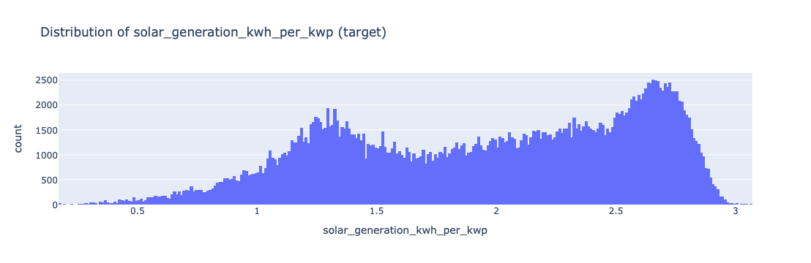
Figure 1Distribution of solar generation

Figure 1: Distribution of solar generation
The histogram for the target variable is shown the observations are clustered around 1:00 to 3:00 KWH/KWP/day and lower ( but less abundant) observations are found at the lower end of the range. Another feature of the distribution is that it has more than one concentration of values, meaning that the production of solar energy varies depending on weather conditions, season and location.

A boxplot was also used to examine the spread of solar irradiance and solar generation and to identify any potential outliers. This is important because extreme weather values may affect the prediction of solar energy generation.

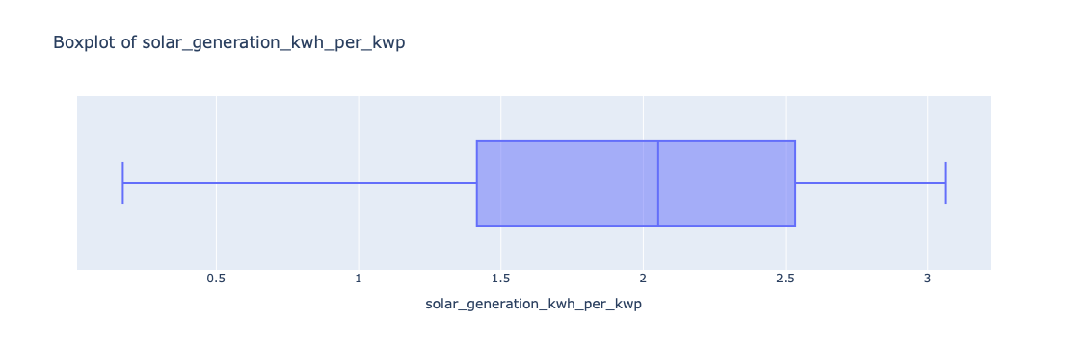
Figure 2 Boxplot of solar generation
Figure 2 boxplot of solar generation The box plot displays the distribution of solar generation values in the data set. The majority of observations fall within the range of about 1.4 to 2.6 kWh KWP, and the entire spectrum ranges from approximately 0.2 to 3.1
KWHKWP. This indicates that solar generation fluctuates over the observations, as is to be expected as a result of fluctuations in the amount of solar energy that can be generated from weather and environmental conditions. The box plot is also helpful for detecting unusually high or low values of generation before proceeding to the next step of analysis.

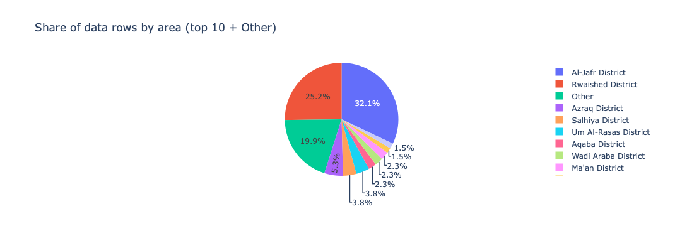
Figure 3 Distribution of data rows by area
Figure 3 data rows distribution by area the pie chart shows how the observations are distributed across the different areas in Jordan the largest percentage of the data set is at al jafr and at Rwaished, with the areas in between having smaller percentages than these. this difference is primarily associated with the assignment of grid points to nearby places and not the geospatial density of solar data. this is significant for the project because the location may influence the Weather conditions, Which also may influence the generation of solar energy.

Bivariate Analysis
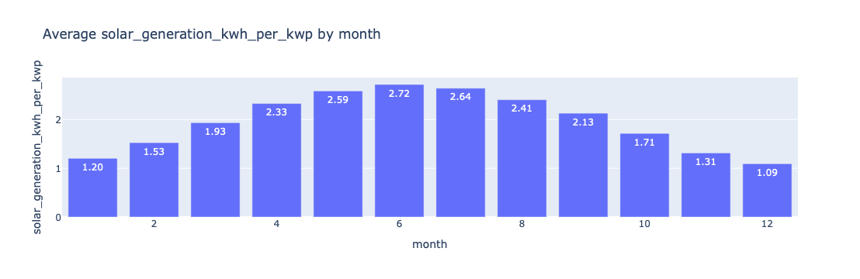
Figure 4 average solar generation by month
Figure4 Average solar generation by month the graph is a bar chart depicting the seasonal trend of solar generation the generation is the highest in summer, around the month of June and July and lowest in winter the generation starts to fall after the summer peak, towards the end of the year the pattern is relevant to the project due to its relation to solar generation and can be used to represent the seasonal variations in solar generation in the model.

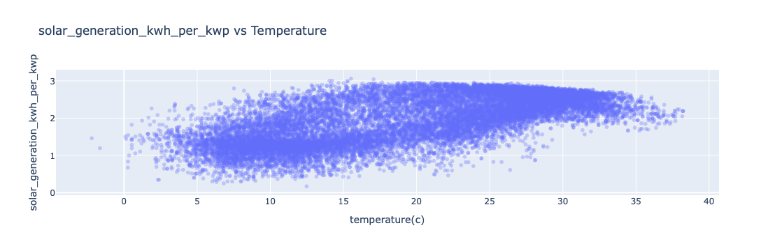
Figure 5 solar generation vs temperature
The scatter plot shows an overall positive relationship between temperature and solar generation. solar generation generally increases as temperature rises, especially from lower to moderate temperatures, However the points become more spread out at higher temperatures which suggests that temperature alone does not fully explain changes in solar generation. Other weather factors such as solar irradiance and cloud cover also affect the amount of energy produced. this relationship is relevant to the pr because temperature is one of the weather variables that can help the model predict solar generation.

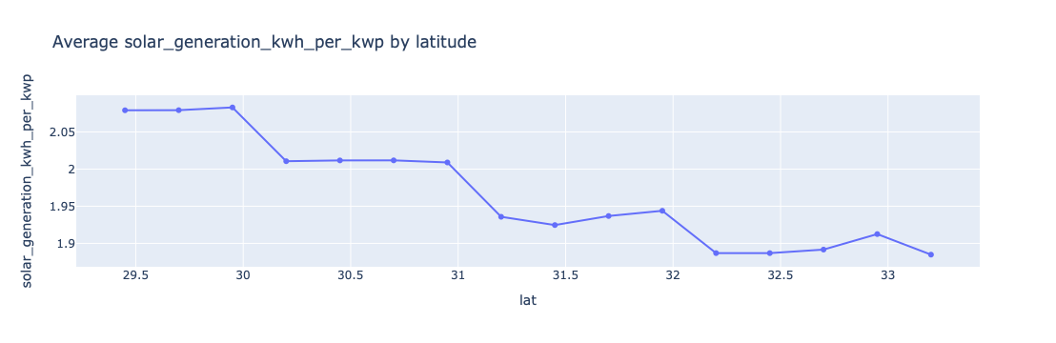
Figure 6 Average solar generation by latitude
As shown in the line chart, the amount of solar energy that can be generated in Jordan varies by latitude. the average generation is higher at the lower latitudes and generally lower with increasing latitude this indicates that the average solar generation at sites in the southern region of Jordan is greater than in the northern region geographical location is important to the project as it can affect solar energy availability which may in turn help to predict solar generation.
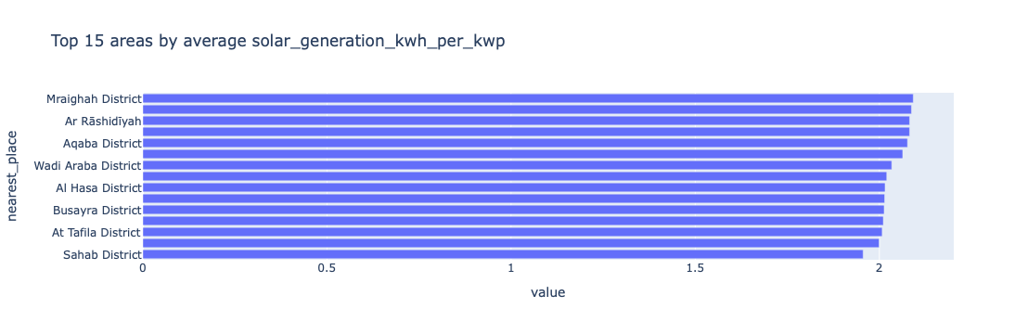
Figure 7 Top 15 areas by the average solar generation
The top 15 areas in the data set are used to compare the average solar generation. the best performing are in the South and desert regions such as aqaba, Wadi araba, ma’an and al jafr this is similar to the previous latitude analysis. which found high solar production in the southern areas the result suggests that location is an important factor when predicting solar energy generation.

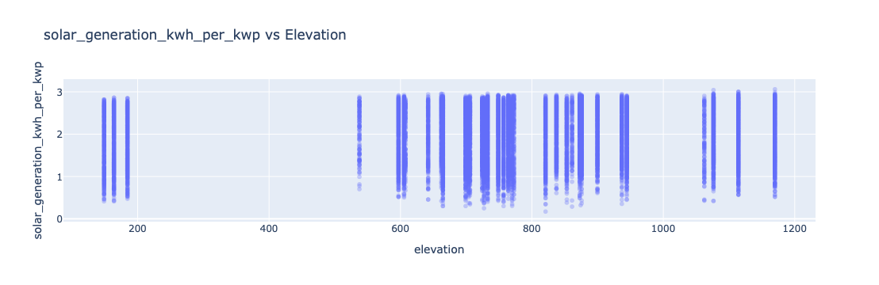
Figure 8 solar generation vs elevation
A scatter plot displays the data for solar generation and the elevation. no single or clear trend is seen between the two variables with both low and high generation values occurring at all elevation levels. this indicates that elevation has a weaker influence than for example solar irradiance temperature season and location on solar generation.

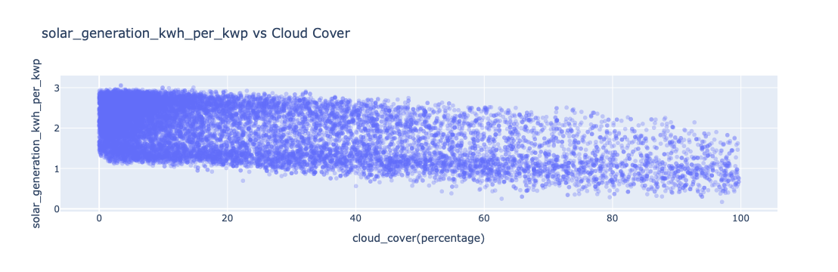
Figure 9 solar generation vs cloud cover
The scatter plot shows a clear negative relationship between cloud cover and solar generation as cloud cover increases, solar generation generally decreases particularly at higher cloud cover levels this indicates that cloud cover is an important factor affecting solar energy generation and is therefore relevant to the prediction model.
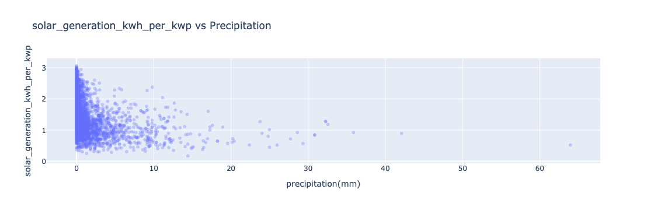
Figure 10 solar generation vs precipitation

The scatter plotted can be seen that for the majority of observations, there is no precipitation recorded, and for larger precipitation levels, there is generally a lower solar generation during rainy days the solar generation is significantly reduced but this could be due to the fact that the cloud cover also tends to be higher during rainy days it indicates that the precipitation has an impact on the solar generation but the impact can be a compound effect with respect to cloud cover.

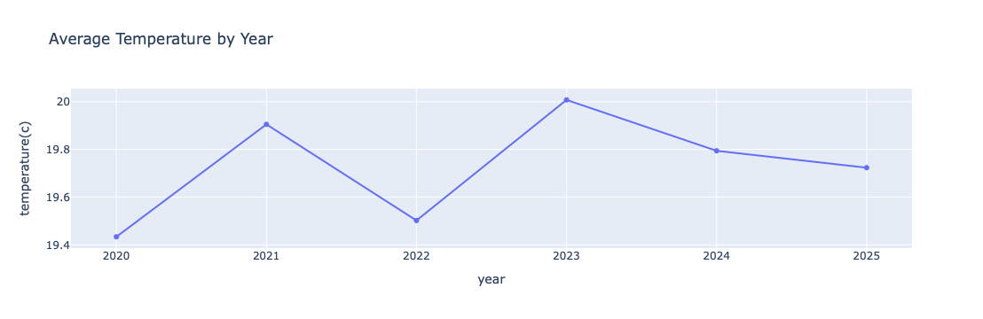
Figure 11 average temperature by year
The line chart shows that the average temperature remained relatively stable between 2020 and 2025,with small fluctuations from year to year the highest average temperature occurred in 2023 while 2020 had the lowest there is no clear continuous upward trend over the six year. This analysis is useful because it provides context for understanding temperature variation in the data set and its potential relationship with solar generation.

Multivariate Analysis

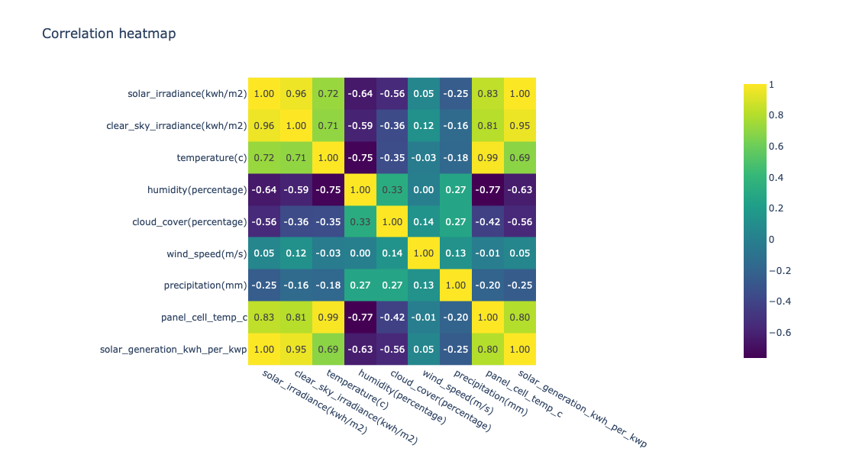
Figure 12 correlation heatmap
The Correlation heatmap is used to show a relationship between major weather parameters, panel cell temperature (engineered) and target variable. Solar irradiance has a very strong positive correlation with solar generation (1.00), while clear-sky irradiance also has a strong positive correlation (0.95). Panel cell temperature has a strong positive correlation with solar generation (0.80). On contrary to this, humidity and cloud cover have a negative correlation with solar generation (-0.63 and -0.56 respectively). The relationships show that solar radiation, heat and moisture levels and clouds are significant factors to predict photovoltaic power production.
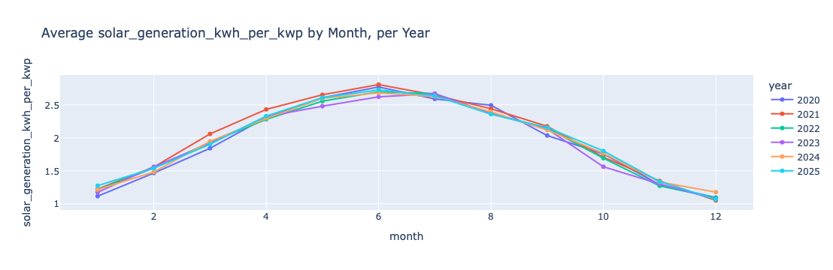Figure 13 Average solar engineer by month and year
The line chart shows a consistent seasonal pattern across all year. solar generation increases from the winter months and reaches its highest levels around June and July, before decreasing again toward the end of the year. the similar pattern across different years suggests that solar generation is strongly influenced by seasonal changes and that the yearly pattern is relatively stable. this supports the use of month and cyclical day-of-year features in the prediction model.

Data primary cleaning and transformation
The raw data set required several cleaning and transformation steps before it was used for analysis and machine learning each step was performed to improve data quality consistency and readability,

Step one library set up an environment all necessary Python libraries were imported including pandas numpy plotly and other libraries required for data analysis and visualization.
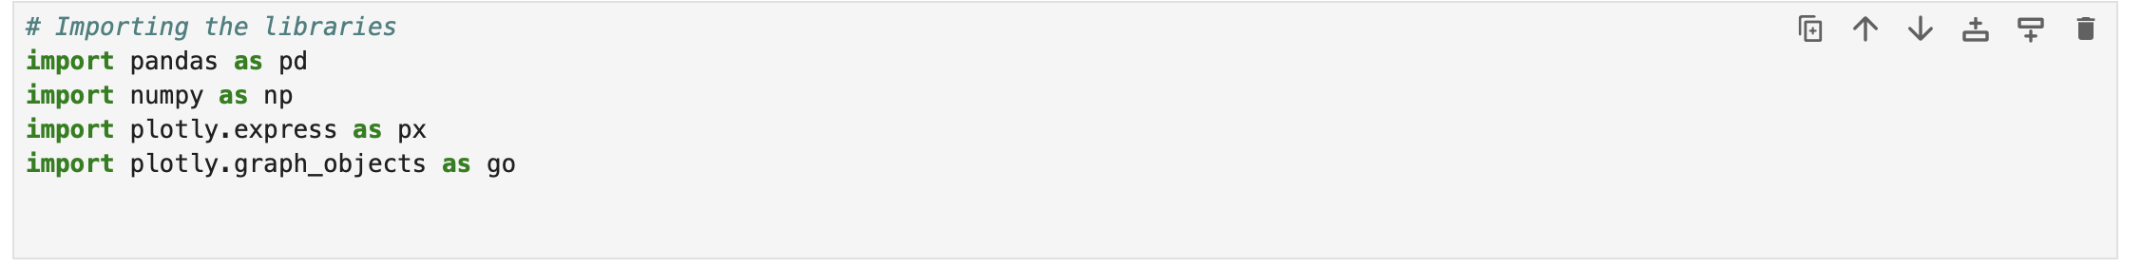
Step two data loading and column renaming the NASA power data set was loaded from a CSV file the original NASA parameter codes were renamed into clear and descriptive column names to make the variables easier to understand and use throughout the analysis

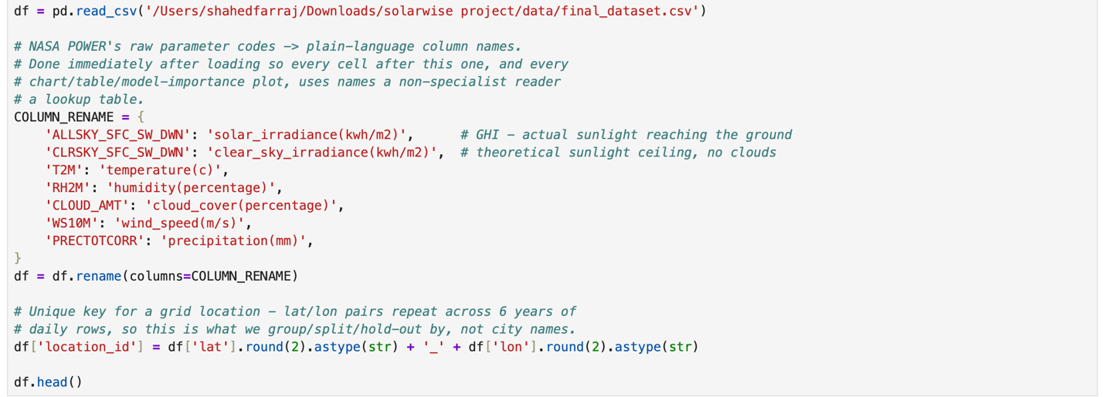
Step three creating a unique location identifier a unique location ID was created using the latitude and longitude values the coordinates were rounded to ensure that the same geographical location was consistently identified across the dataset.

Step 4 Data type missing value and data set size check: to ensure accuracy we have verified columns name data type and nullity of this set all weather parameters are numbers whereas locations have been saved as string values there are 290,023 data points and 13 features that have at least one value for each feature variable also we verified if this data set covers all of our desired grid points an observation dates for 2020 to 2025.
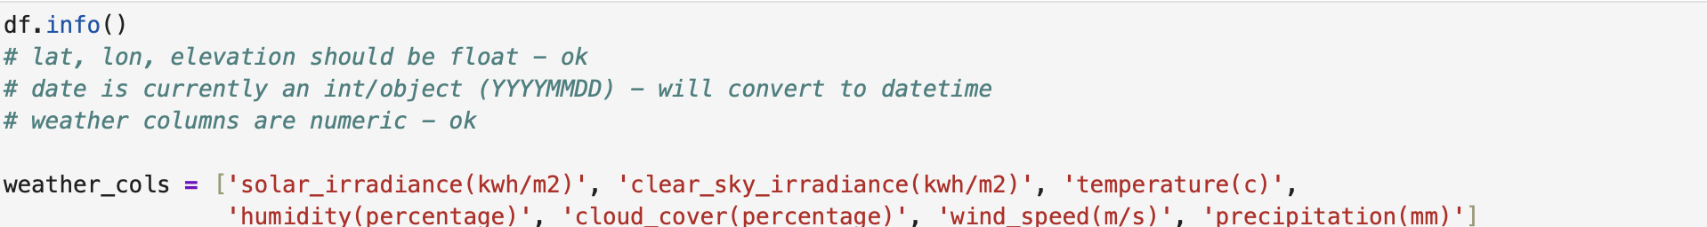

Step 5 outlier detection and removal the temperature variable was checked for physically implausible values a reasonable range of -10°C to 55°C was defined an observations outside this range were identified as outliers and removed a total of 5 rows were removed descriptive statistics were then recalculated to confirm the data after outlier removal.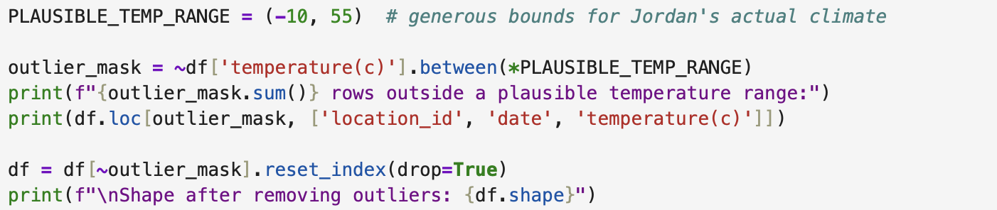

Step 6geographical coverage validation the geographical coverage of the data set was checked using a map of the weather data locations this was done to ensure that the grid points provide spatial coverage across Jordan including the northern southern and eastern desert regions rather than being concentrated in only a few areas the check confirmed 131 distinct weather data locations covering Jordan. 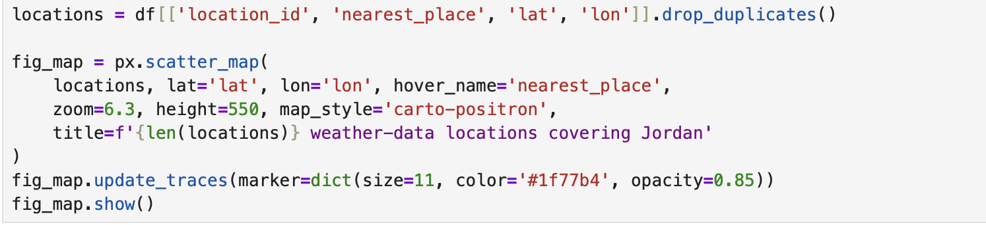

Step 7 duplicate and missing value removal:first duplicates are detected then deleted so no duplicate locations and observations app ear again on either side of this process there are 2871 exact duplicates of data that needed to be deleted -999 is used by NASA power to indicate when there are no data on weather conditions etc thus they are set to nan and columns having nulls for their respective weather data points have been dropped out of data set altogether it is better not to use imputations since there are few cases here compared with all your data set together.
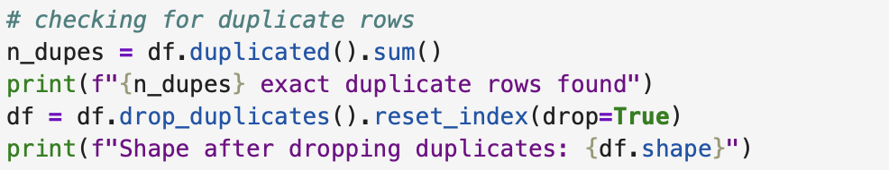
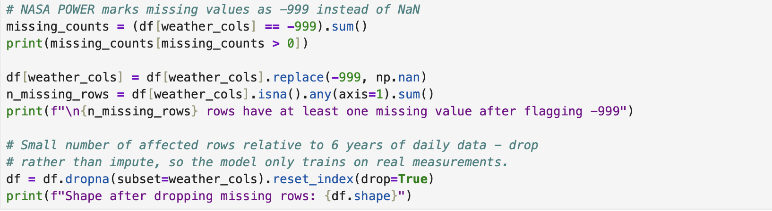
Step 8 statistical range validation basic descriptive statistics were calculated to validate the numerical ranges of the data set and identify any physically unrealistic values the minimum maximum mean and standard deviation were reviewed for the main numerical variables to ensure that the clean data were within reasonable ranges before proceeding to the analysis and modeling stages


Data Visualization and Insights
The project interactive visualizations to analyze solar energy potential across Jordan the main visualizations include maps rankings monthly trend charts and district comparisons these visualizations help identify differences in solar production solar irradiance cloud cover and temperature across locations and throughout the year.
Chart1- Where are the strongest solar resource?
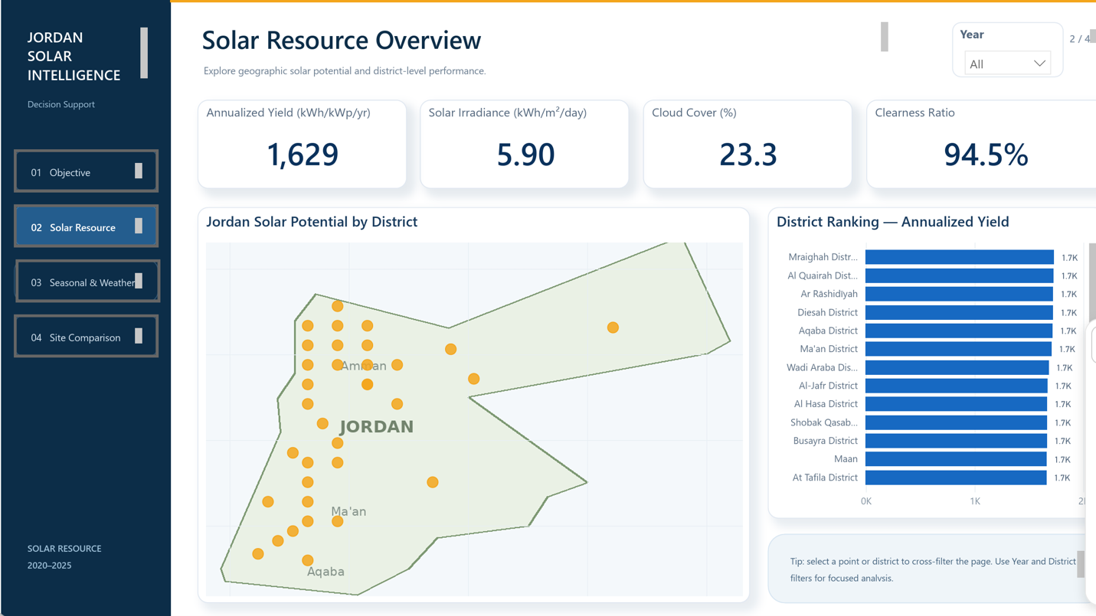
Figure 14 solar resource overview dashboard

Inside the geographical distribution of the solar potential in Jordan is displayed on the dashboard the national average annualized yield is 1629 kwh/kwp/ year and the average solar irradiance is 5,90 kwh/m2/day. the dashboard also shows a national cloud cover of 23.3% and a clearness ratio of 94.5%. The map shows the solar potential across 131 geographic locations in Jordan while the ranking chart compares districts according to annualized yield insight derived the dashboard helps identify areas with stronger solar resources and provides a geographic view of solar potential across Jordan.

Chart2-When is solar production strongest?

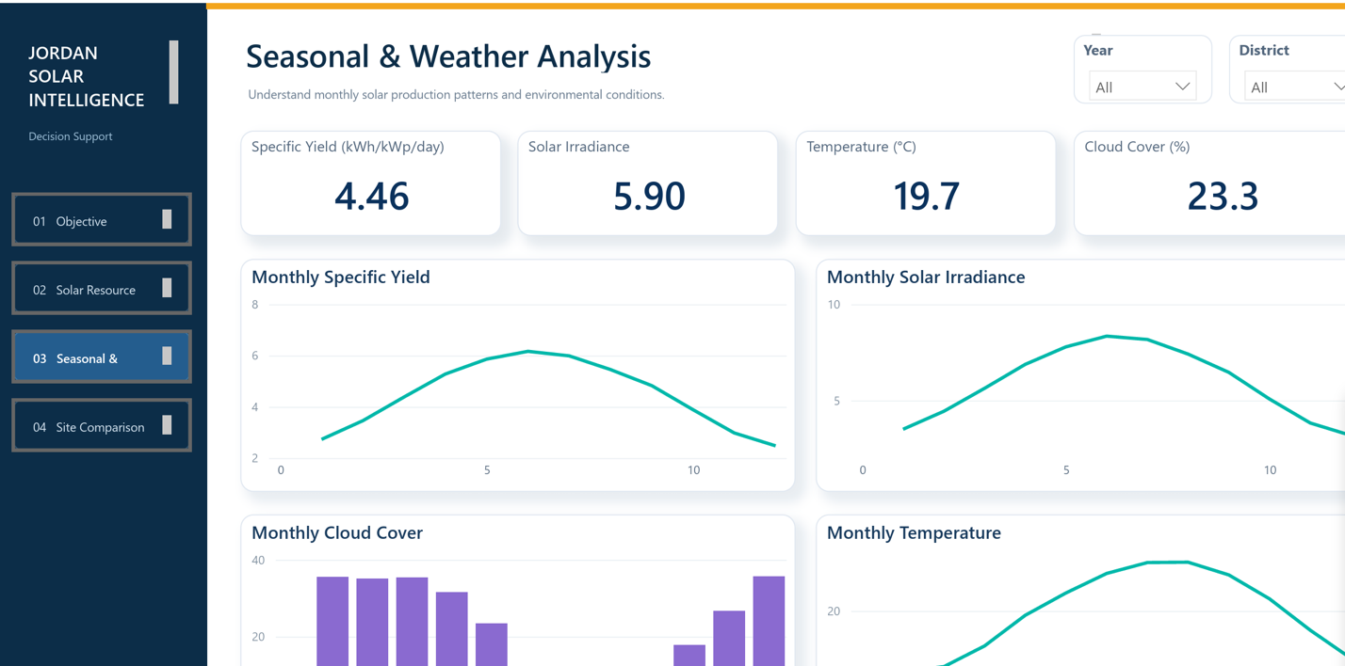
Figure 15 Seasonal & Weather dashboard
Specific yield solar irradiance cloud cover and temperature insight derived solar production and solar irradiance has a distinct seasonal trend and cloud cover and temperature offers environmental context these patterns can be viewed and explored by year and district with interactive filters on the dashboard.
Chart3 – Which districts perform best?

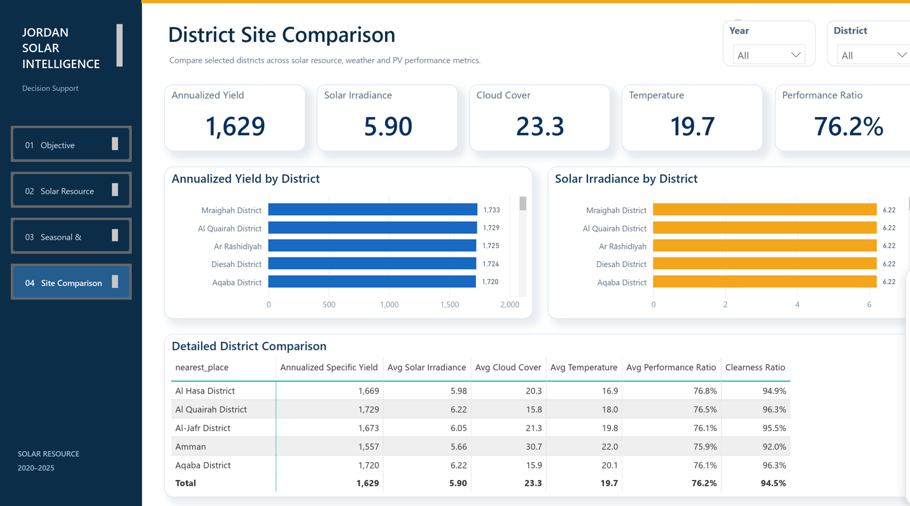
Figure 16 District site comparison
The comparison page ranks districts according to annualized yield and compares solar irradiance, cloud cover, temperature, performance ratio, and clearness ratio.
Insight Derived: Mraighah District has the highest annualized yield among the shown districts at approximately 1,733 kWh/kWp/year, followed by Al Quairah District at 1,729 and Ar Rāshidīyah at 1,725.

Advanced analytics and AI modeling
problem framing
this is an example of supervised learning problem for regression type the target variable solar_generation_kwh_per_kwp is an integer representing to understand relationships between weather patterns geography and solar power production use those relationships for predicting future solar power generation based upon new data points.
1-Preprocessing Pipeline and Train/Test Split.
For machine learning purposes, we have prepared this data set with relevant weather and location variables as inputs, and solar_generation_kwh_per_kwp as output variable. Selected parameters are solar radiation, clear sky radiation; temperature; humidity; cloud cover; wind speed; precipitation; latitude; longitude; and altitude.
Data is split between a training set and an test set so that we can train our model with some data points while testing it out on others. Both numerical and categorical features are processed based upon type while feeding them for ml model training. 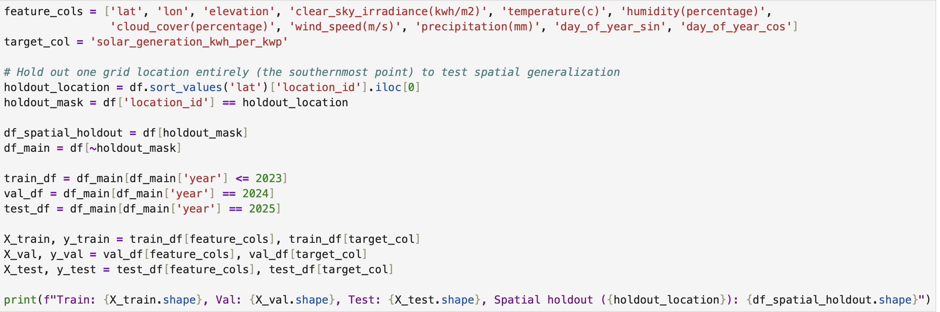

2- Baseline and model comparison

There regression models were trained and evaluated to predict solar generation kWh per KWP Linear regression, Random forest, and XGBoost. MAE, RMSE,and R2 were used to evaluate the model performance with respect to validation set.
All three models are performing well so there is an excellent correlation between weather conditions locations and solar power generation However, XGBoost had the best overall performance with the lowest may of 0.041 930 the lowest are MSE of 0.078504 and the highest are two of 0.982127 random forest was the second best model with an R2 of 0.978942 while linear regression had an R2 of 0.970815 .
Therefore, XGBoost was selected as the final predictive model because it provided the most accurate predictions while minimizing prediction errors. 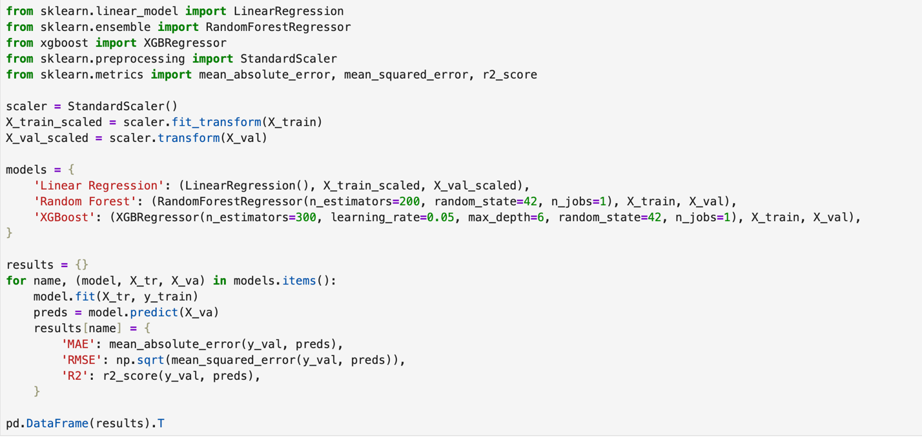
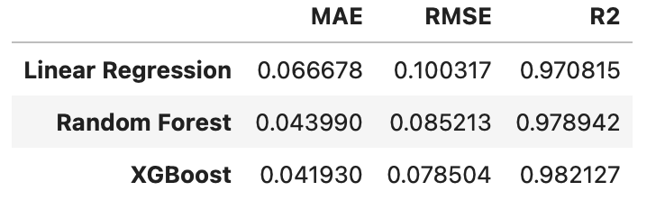

3- Predicted vs actual & residuals (best model)
The scatter plot compares the actual and predicted values of solar generation using the best performing model XGBoost. Most observations are closely distributed around the diagonal reference line indicating that the model predictions are generally close to the actual solar generation values. this confirms the strong predictive performance of xg boost on the validation dataset.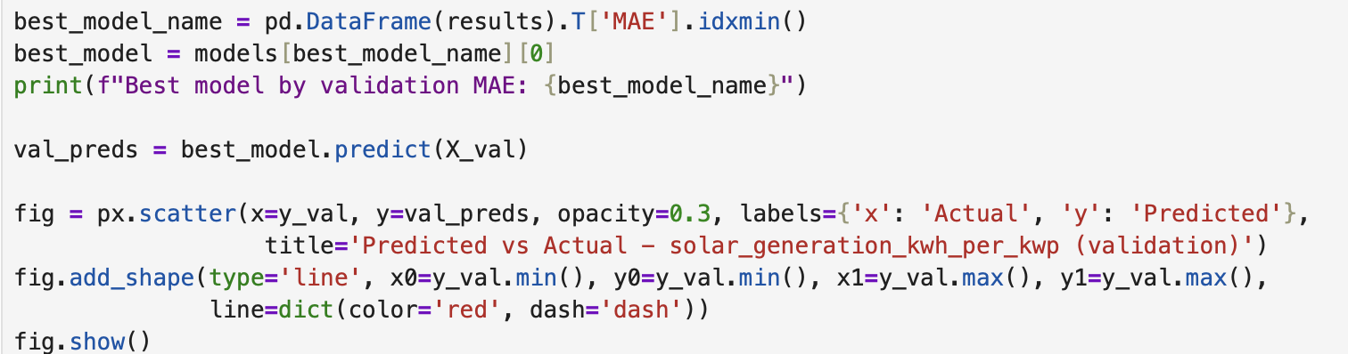
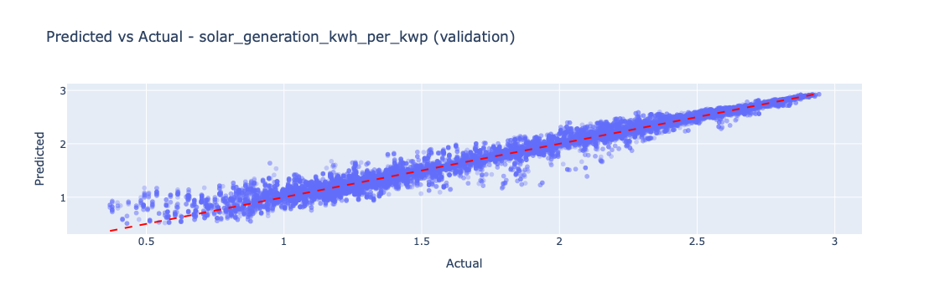
Figure 17 Predicted vs actual

-Residuals distribution
The residual distribution shows the difference between the actual and predicted solar generation values on the validation set the residuals are concentrated around 0 indicating that the XGBoost model does not show a strong systematic over prediction or under prediction pattern this supports the reliability of the model predictions on the validation data.
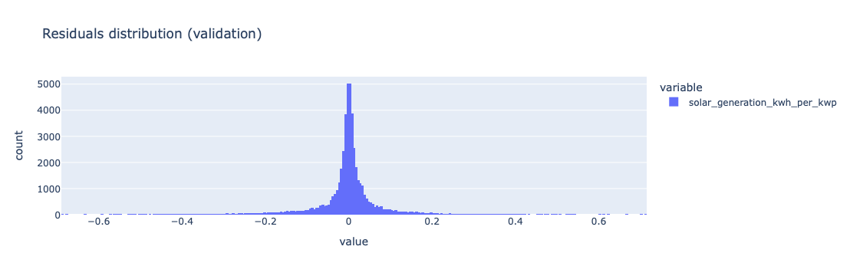
Feature Importance
A feature importance plot shows that some variables are more important for predicting solar power output with an xgboost algorithm. The most significant parameter is clear sky radiation, which is also very much related with clouds and rainfall. Other factors such as humidity, temperature, day of year, wind speed, elevation, latitude, and longitude are of little importance.
It means that solar power generation is mainly due to sunlight availability and weather conditions. Clear sky solar radiation has a relationship with how much sunlight is available for generating electricity.
Insight The model is mainly based on irradiance related parameters for predicting solar power production whereas location parameters have much less impact. It means that solar radiation is one of the most important factors for estimating solar power production from these data sets.
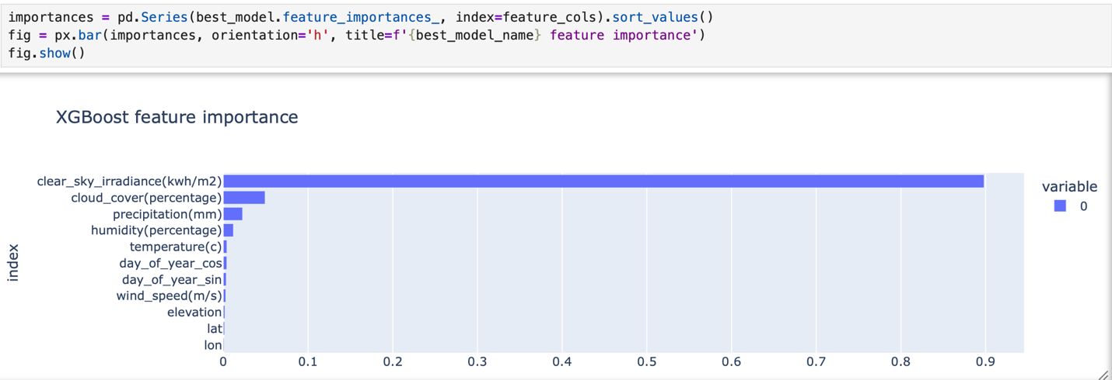
Evaluation of final Test sets spatial generalization
The final evaluation was done on the 2025 test set to assess how well the selected XG boost model performs on unseen data the model had a test MAE of 0.0414 RMSC of 0.0796 and in R2 score of 0.9825 these results show that the model is very accurate and explains about 98.25% of the variation in solar generation also a spatial generalization test was done where one point was left out completely from the training set the model had a spatial holdout MAE of 0.0281 RMSE of 0.0551 and R2 of 0.9900 it shows how good it is to predict things even if you are not trained on that particular area key insight the high R2 scores on both the test set and the unseen location show that boost generalizes well across both time and geographic location making it a good model for predicting solar generation.
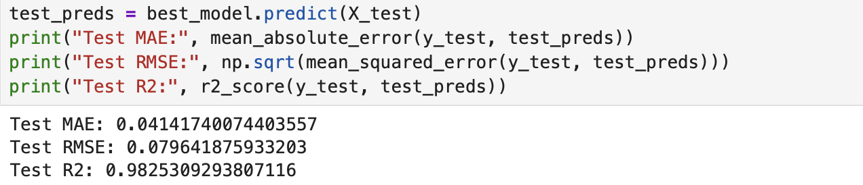

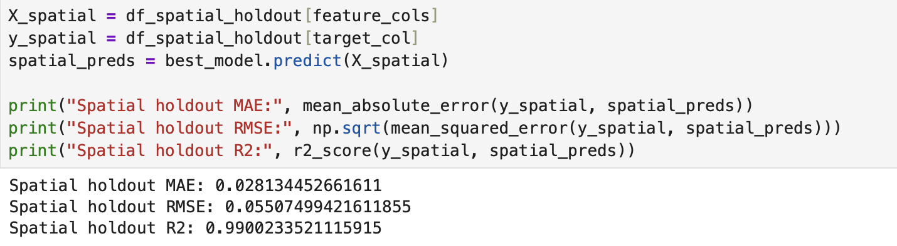

Tools research and selection effort
tools have been evaluated for this initiative's creation Python jupyter notebook pandas numpy sicket learn boost plotly and power BI was used as main tool for this project I chose
Python since it has many library packages to do analytics visualization machine learning tasks easily and efficiently the primary tool for coding on
Jupiter notebook was utilized here this enabled data preprocessing cleansing analytical work along with visualizations and ML models development and documentation process data was loaded with help pandas and numpy cleaned up by removing nulls and duplicate entries while also doing some statistics on them we use ticket learn to do data preprocessing split of trained test sets and model evaluation and implementation of linear regression random forest etc XGBoost is chosen for this task since they performed very well with their predictions on solar power generation data set also it helped us understand what were important for each feature the plotly library was utilized for creating interactive graphs including a prediction versus actuals graph along with residuals plots power bi has been chosen as our last bqs dashboard helps you visualize data for better understanding of solar power generation trends and analytics with graphics charts visualizations filters available on demand from your dashboard these were chosen due their compatibility such as data preprocessing and exploratory analyzes ML models generation graphs for visualizing results along with reports on business performance metrics at end of process.

Project Deployment Effort - Use case.
This product could also function as an interactive Power BI dashboard powered by a python based ml model. The users of business are able on this website for tracking of their solar power consumption; they could analyze climate data along with locations where things happen then compare these results against those generated by an ml algorithm.
You could integrate your xgboost model with an existing system that processes current and future weather, locations through this process pipeline. Then, The trained model will produce solar generation forecast which is going to be imported back on power BI dash board.
Business Use Case
for example an energy consultant and architect of a solar power plant may want to access this information through their web-based interface (the dashboard).
Monitor predicted solar generation.
Compare predicted and actual generation.
Determine which climatic factors are most influential for power production.
Evaluate model performance.
Decision making on renewable energy development and resources management support.
Proposed Deployment
You could deploy this prototype through an automated process for your data pipeline needs. Data will also be gathered at regular intervals; then processed again through current pre-processing techniques before being fed through an xgboost algorithm for prediction purposes where results are saved as files/databases respectively. Then power BI would update this information for you so that your reports are up-to-date on-line via an online analytics tool called a dashboard.
Implementation Steps
This project has gone through these steps sequentially.
Data Collection – collected solar generation, weather and location information. Data Cleaning Removing duplicates; handling of null data and extreme temperatures (physically).
Exploratory Data Analysis was done to explore distribution and statistics; correlation among variable sets. Data Visualization, created graphs and a chart of this data set for understanding its characteristics and identifying key trends/trends.
Feature Selection Selected weather, geographic, and time related variable for use as feature set of models. Train / Validate / Test Split – used to do this by splitting my dataset at some point for not-leakage of information while testing it afterwards.
Model Training Trained and compared Linear Regression, Random Forest, and XGBoost models. Model Evaluation Comparison of MSE, rms ee r2.
Best Model Selection Selected xgboost based on its validation performance. Model Interpretation – analyzed features for importance, made predictions on them versus actual results and residuals.
Final Testing – evaluated the chosen model for the 2025 test set, and did a spatial generalization check. Deployment Concept - Integrate this ml model within an existing process flow, then integrate predictions from that system on power BI dashboards.
Deployment objective final -to give customers a live view on their energy production history and forecast based upon ml models so they can make better decisions about things going forward. Model Training - Trained and compared Linear Regression, Random Forest, and XGBoost models.
8. Model Evaluation - Compared the models using MAE, RMSE, and R².
9. Best Model Selection - Selected XGBoost based on its validation performance.
10. Model Interpretation - Analyzed feature importance and generated predicted-versus-actual and residual plots.
11. Final Testing - Evaluated the selected model on the 2025 test set and performed a spatial generalization check.
12. Deployment Concept - Proposed integrating the trained model into a scheduled pipeline and connecting its prediction output to the final Power BI dashboard.
Final deployment goal: provide business users with an interactive dashboard that combines historical solar-generation analysis with machine-learning predictions to support data-driven decision-making.
Results

The project achieved strong results in predicting solar power generation. After comparing several machine learning algorithms, XGBoost was selected because it achieved the best validation performance. On the final 2025 test set, the model achieved an MAE of 0.0414, an RMSE of 0.0796, and an R² of 0.9825, meaning that it explains approximately 98.25% of the variance in solar generation. The spatial generalization test also produced strong results, with an R² of 0.9900, indicating that the model performs very well when applied to a location that was not included in the training data.

The most valuable insight came from the XGBoost Feature Importance chart. Clear-sky irradiance was the strongest predictor, followed by cloud cover and precipitation. This indicates that solar radiation and weather conditions are the primary factors contributing to solar power generation in this dataset, while geographic variables such as latitude, longitude, and elevation, as well as wind speed, had relatively low importance.

Overall, these results demonstrate that the selected model provides accurate predictions across both time and geographic locations. The Predicted vs Actual chart is one of the most important results because most observations are closely distributed around the diagonal reference line, showing that the predicted values are generally close to the actual solar-generation values. This confirms the strong predictive performance of the XGBoost model.

References
All sources used in this project — data, domain assumptions, and the tools/libraries it's built on. Useful for the report's references section and for anyone continuing the project.

Data Sources

- **NASA POWER** — the weather/solar dataset this whole project is built on.
[power.larc.nasa.gov](https://power.larc.nasa.gov/)
- **NASA POWER API docs** — the exact endpoint used to pull daily data.
[power.larc.nasa.gov/docs/services/api/temporal/daily](https://power.larc.nasa.gov/docs/services/api/temporal/daily/)
- **OpenStreetMap Nominatim** — used to turn addresses into coordinates, and to check whether a point is really inside Jordan's border.
[nominatim.openstreetmap.org](https://nominatim.openstreetmap.org/)
- **Nominatim usage policy** — the rate-limit rules (1 request/second) this project follows when calling it.
[operations.osmfoundation.org/policies/nominatim](https://operations.osmfoundation.org/policies/nominatim/)
Domain / Industry Standards (assumptions used in the model)

- **Standard solar panel sizes and wattages** — panel dimensions and wattage assumption (450W monocrystalline).
[The Green Watt](https://www.thegreenwatt.com/standard-solar-panel-sizes-and-wattages-dimensions/)
- **Solar panel size and wattage guide** — panel efficiency assumption (21%).
[Palmetto](https://palmetto.com/solar/choosing-the-right-solar-panel-size-and-wattage)
- **Middle East Solar Compliance 2026: Jordan** — residential system size range (1–5.4 kWp), Net Billing regulation (Bylaw 58, 2024).
[SurgePV](https://www.surgepv.com/solar-compliance/middle-east)
- **JEPCO official tariff page** — the tiered residential electricity pricing used for the JOD savings calculation.
[JEPCO](https://www.jepco.com.jo/ar/Home/فئات-وشرائح-تعرفة-الكهرباء)

Tools & Libraries

- **Python** — [python.org](https://www.python.org/)
- **Jupyter Notebook** — used to build and run `solar_worth_it.ipynb`.
[jupyter.org](https://jupyter.org/)
- **pandas / NumPy** — data handling and numeric computation.
[pandas.pydata.org](https://pandas.pydata.org/) · [numpy.org](https://numpy.org/)
- **scikit-learn** — Linear Regression, Random Forest, train/test tooling, metrics.
[scikit-learn.org](https://scikit-learn.org/)
- **XGBoost** — the best-performing model in this project.
[xgboost.readthedocs.io](https://xgboost.readthedocs.io/)
- **Plotly** — every chart in the notebook and the app.
[plotly.com/python](https://plotly.com/python/)
- **Streamlit** — the web app framework the whole app is built with.
[docs.streamlit.io](https://docs.streamlit.io/)
- **Folium** — the interactive map used for "pick your location on a map."
[python-visualization.github.io/folium](https://python-visualization.github.io/folium/)
- **streamlit-folium** — lets a Folium map be clicked inside a Streamlit app.
[github.com/randyzwitch/streamlit-folium](https://github.com/randyzwitch/streamlit-folium)
- **streamlit-js-eval** — powers the "Detect my location" browser GPS feature.
[github.com/aghasemi/streamlit_js_eval](https://github.com/aghasemi/streamlit_js_eval)
- **joblib** — saving/loading the trained model and features for the app.
[joblib.readthedocs.io](https://joblib.readthedocs.io/)

Deployment

- **Git** — version control, used to push the project to GitHub.
[git-scm.com](https://git-scm.com/)
- **GitHub** — where the code is hosted.
[github.com](https://github.com/)
- **Streamlit Community Cloud** — free hosting for the live app.
[share.streamlit.io](https://share.streamlit.io/)

